CSC 352/452: Database Programming
Mid-term Exam
(300 Points)
Late exams will not be accepted or graded.

CSC 352/452-501: Due on Sunday, 10/14/2012 at midnight.
CSC 352/452-510: Due on Monday, 10/15/2012 at midnight.

- The mid-term exam is a take-home, open-book, and open-notes exam. You can use any of your class notes and readings to complete the exam.
- You may not consult in any form with any other person while doing this take-home exam.
- Please submit a text file containing all your answers to COL before or on due date.
- If you submit a blank/wrong/image file, you will simply receive a grade of zero.
- Please keep a copy for yourself.
Part I) (120 points)

There are a total of 12 questions. Each question is worth 10 points.

Assume that the tab1 table exists in the underlying database.

Q1. In the DECLARATION section of a PL/SQL block, you create these variables:

v_term, v_session VARCHAR2(6);

Why does this statement cause an error?

A. The CONSTANT keyword is missing.
B. A value must be assigned to each variable.
C. Multiple variables cannot be declared in the same statement.
D. The NOT NULL constraint for each variable was not declared.

Q2. Evaluate the following CURSOR statement:

DECLARE
CURSOR cur_1 (p_age NUMBER(3) := 18) IS
SELECT col1, col2, col3
FROM tab1
WHERE col15 > p_age;

Why will this statement cause an error?

A. The SELECT statement is missing the INTO clause.
B. The size of the p_age parameter cannot be specified.
C. The default value of the p_age parameter cannot be specified.
D. PL/SQL does not allow you to pass parameters into cursors.
E. None of the above

Q3. Which guideline relates to a CURSOR FOR Loop?

FOR v_idx IN cursor_name LOOP
statement1;
statement2;
......
END LOOP;

A. It requires an OPEN cursor_name statement.
B. It does not require a FETCH statement.
C. The user must explicitly declare the v_idx in the DECLARATION section.
D. None of the above.

Q4, In PL/SQL, records of the same declared type cannot be compared for equality by using the equality operator (=) as follows,

......
IF v_rec1 = v_rec2 THEN
DBMS_OUTPUT.PUT_LINE('v_rec1 = v_rec2');
END IF;
......

A. FALSE
B. TRUE

Q5. In PL/SQL, you cannot check whether two nested tables of the same declared type are equal by using the equality operator (=) as follows,

......
IF v_tab1 = v_tab2 THEN
DBMS_OUTPUT.PUT_LINE('v_tab1 = v_tab2');
END IF;
......

A. FALSE
B. TRUE

Q6. What is the value of v_2 when the following PL/SQL block is executed?

DECLARE
v_1 NUMBER;
v_2 BOOLEAN;
BEGIN
UPDATE tab1
SET col11 = 90
WHERE col22 > 9;

SELECT COUNT(*)
INTO v_1
FROM tab1;

v_2 := SQL%FOUND;
END;

A. The value is FALSE if and only if the tab1 table is empty.
B. The value is TRUE if and only if the tab1 table is empty.
C. The value is always FALSE.
D. The value is always TRUE.
E. None of the above

Q7. Evaluate this IF statement:

IF v_num >= 40 THEN
v_example := 1;
ELSIF v_num >= 15 THEN
v_example := 2;
ELSIF v_num <= 8 THEN
v_example := 3;
ELSIF v_num >= 11 THEN
v_example := 4;
ELSE v_example := 5;
END IF;

If v_num is 10, which value would be assigned to v_example?

A. 1
B. 2
C. 3
D. 4
E. 5

Q8. Which predefined Oracle Server exception would you use to handle a run-time error caused by a SELECT statement that returns more than ONE row?

......
SELECT col1
INTO v_1
FROM tab1;
......

A. INVALID_NUMBER
B. NO_DATA_FOUND
C. ROW_COUNT
D. TOO_MANY_ROWS

Q9. To which of the following will an exception raised in the DECLARATION section of a PL/SQL block propagate?

<<B_1>>
DECLARE
v_1 NUMBER := 90;
......
BEGIN
......
<<B_2>>
DECLARE
v_2 NUMBER := 0;
v_3 NUMBER := v_1 / v_2; -- Run-time error, propagate to?
......
BEGIN
......
EXCEPTION
WHEN ......
WHEN ......
WHEN OTHERS THEN
DBMS_OUTPUT.PUT_LINE('ERROR (B_2)!');
END B_2;
<<B_3>>
DECLARE
v_3 NUMBER := 3;
......
BEGIN
......
EXCEPTION
WHEN ......
WHEN ......
WHEN OTHERS THEN
DBMS_OUTPUT.PUT_LINE('ERROR (B_3)!');
END B_3;

......
EXCEPTION
WHEN ......
WHEN ......
WHEN OTHERS THEN
DBMS_OUTPUT.PUT_LINE('ERROR (B_1)!');
END B_1;

A. The B_1 block’s DECLARATION section
B. The B_1 block’s EXECUTION section
C. The B_1 block’s EXCEPTION section
D. The B_2 block’s DECLARATION section
E. The B_2 block’s EXECUTION section
F. The B_2 block’s EXCEPTION section
G. The B_3 block’s DECLARATION section
H. The B_3 block’s EXECUTION section
I. The B_3 block’s EXCEPTION section

Q10. Consider the following SELECT statement:

DECLARE
v_count NUMBER;
BEGIN
SELECT COUNT(*)
INTO v_count
FROM tab1
WHERE col1 > 0;
END;

What happens if there are no rows satisfying the WHERE condition?

A. COUNT(*) is not valid to use in PL/SQL.
B. A NO_DATA_FOUND exception is raised.
C. A TOO_MANY_ROWS exception is raised.
D. The SELECT statement executes successfully.
E. None of the above

Q11. Nested blocks are allowed in the DECLARATION section of a PL/SQL block.

A. FALSE
B. TRUE

Q12. How many records will be inserted into the tab1 table after the following PL/SQL block has been executed successfully?

DECLARE
v_count NUMBER := 0;
BEGIN
DELETE FROM tab1;
COMMIT;
BEGIN
FOR i IN 5..7 LOOP
INSERT INTO tab1 VALUES (i, i*10, i+10);
END LOOP;

SELECT COUNT(*)
INTO v_count
FROM tab1;

INSERT INTO tab1
VALUES (v_count, v_count+1, v_count+2);
COMMIT;

INSERT INTO tab1 VALUES (42, 25, 36);
INSERT INTO tab1 VALUES (99, 205, 306);
END;
BEGIN
INSERT INTO tab1 VALUES (7, 82, 92);
ROLLBACK;
END;
BEGIN
FOR i IN REVERSE 4..45 LOOP
IF i = 10 or i = 25 or i = 35 or i = 45 THEN
ROLLBACK;
INSERT INTO tab1 VALUES (i*20, i*30, i*40);
ELSE
INSERT INTO tab1 VALUES (i*2, i*3, i*4);
END IF;
END LOOP;
COMMIT;
END;

BEGIN
FOR i IN 1..9 LOOP
FOR j IN i+3..15 LOOP
IF i = 4 OR i = 6 OR i = 7 THEN
ROLLBACK;
ELSE
INSERT INTO tab1
VALUES (i*20, i*30, j*40);
END IF;
INSERT INTO tab1 VALUES (i*21, i*31, j*41);
END LOOP;
INSERT INTO tab1 VALUES (i*211, i*411, i*511);
END LOOP;
COMMIT;
END;

BEGIN
INSERT INTO tab1 VALUES (616, 222, 243);
ROLLBACK;
INSERT INTO tab1 VALUES (77, 88, 99);
END;
COMMIT;
END;

A. 33
B. 34
C. 35
D. 36
E. 37
F. 38
G. 39
H. None of the above
Part II) (180 points)

You are not allowed to create temporary tables, views, functions, or procedures.

Hard coding is not allowed in your program.

The Exception section in your program is optional.

1) (CSC 352 – 60 points | CSC 452 - 50 points)

ABC Airlines Inc. keeps track of its employees in its Human Resources database. The PERSON table contains basic employee information. The EMP_TYPE field indicates whether a person is a full-time employee (F) or a part-time employee (P). The structure of the table is shown below along with some sample records:

PERSON
EMPLOYEE_ID | LAST_NAME | FIRST_NAME | EMPLOYEE_TYPE
NUMBER PK | VARCHAR2(30) | VARCHAR2(30) | CHAR
1000 | Smith | John | F
1170 | Brown | Dean | P
2010 | Fisher | Jane | F
2080 | Brewster | Andre | F
3190 | Clark | Dan | P
3500 | Jackson | Tyler | F
4000 | Miller | Mary | F
4100 | Jackson | Peter | P

An employee (full-time employee as well as part-time employee) can be a pilot. In this case, the information related to pilots is kept inside a separate table PILOT as shown below:

PILOT
EMPLOYEE_ID | PILOT_TYPE
NUMBER PK, FK | VARCHAR2(100)
1170 | Commercial pilot
2010 | Airline transport pilot
3500 | Airline transport pilot

For example, John Smith is a full-time employee and is not a pilot while Jane Fisher is a full-time employee and is also a pilot. On the other hand, Dean Brown is a part-time employee and is also a pilot. However, Dan Clark is a part-time employee but is not a pilot.

a) (0 points) Create and populate the PERSON and PILOT tables described above.

CREATE TABLE person
(
employee_id NUMBER PRIMARY KEY,
last_name VARCHAR2(30),
first_name VARCHAR2(30),
employee_type CHAR
);

INSERT INTO person VALUES (1000, 'Smith', 'John', 'F');
INSERT INTO person VALUES (1170, 'Brown', 'Dean', 'P');
INSERT INTO person VALUES (2010, 'Fisher', 'Jane', 'F');
INSERT INTO person VALUES (2080, 'Brewster', 'Andre', 'F');
INSERT INTO person VALUES (3190, 'Clark', 'Dan', 'P');
INSERT INTO person VALUES (3500, 'Jackson', 'Tyler', 'F');
INSERT INTO person VALUES (4000, 'Miller', 'Mary', 'F');
INSERT INTO person VALUES (4100, 'Jackson', 'Peter', 'P');
COMMIT;

CREATE TABLE pilot
(
employee_id NUMBER PRIMARY KEY,
pilot_type VARCHAR2(100),
CONSTRAINT fk_person_pilot FOREIGN KEY (employee_id)
REFERENCES person(employee_id)
);

INSERT INTO pilot
VALUES (1170, 'Commercial pilot');
INSERT INTO pilot
VALUES (2010, 'Airline transport pilot');
INSERT INTO pilot
VALUES (3500, 'Airline transport pilot');
COMMIT;

b) (60/50 points) Write a PL/SQL anonymous block that accepts an employee’s last name (last_name) from the user input and displays employee’s information.

- If the employee’s last name is NOT in the PERSON table, your program displays information about all employees. Sort your output by the employee name (last name, first name) and employee type.

- If the employee’s last name is in the PERSON table, your program displays the corresponding employee’s information. We may have duplicate last names in the PERSON table. Sort your output by the employee name (last name, first name) and employee type.

Employee’s last name is not case sensitive (e.g., Jackson = JACKSON). You will lose 5 points if you do not use the UPPER (or LOWER) function in your program.

The employee type (“F” or “P”) must be displayed as “Full-Time Employee” or “Part-Time Employee”. You will lose 10 points if you fail to do so.

Test your program. You must ensure that the output of your program matches the following sample output:

Case 1)

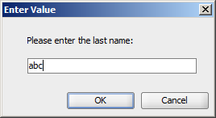

Output:

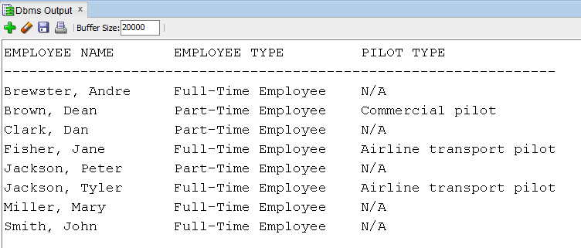

Case 2a)

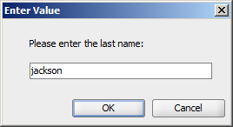

Output:

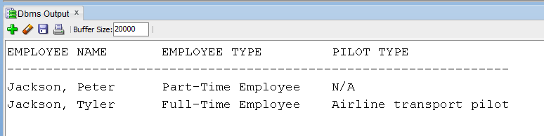

Case 2b)

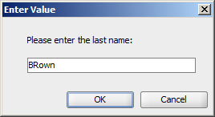

Output:

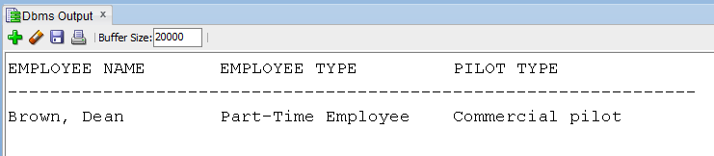

2) (CSC 352 – 60 points | CSC 452 - 50 points)

Based on the tables created in Assignment #1, write a PL/SQL anonymous block to find all employees whose salary is less than the average salary for their department and less than the average salary for the whole company. Please make sure that your program displays each department name and average salary only once. Sort your output by the department name and employee name.

If you modified the tables created in Assignment #1, you need to truncate/delete and re-populate them.

The output of your program must match the following:

Company Average Salary: $2,853.33
------------------------------------------
Department Name: ACCOUNTING
Department Average Salary: $2,750.00

Employee Name: STEEL
Employee Salary: $2,500.00
------------------------------------------
Department Name: IT
Department Average Salary: $2,100.00

Employee Name: ADAMS
Employee Salary: $2,000.00
Employee Name: MILLER
Employee Salary: $1,000.00
------------------------------------------
Department Name: RESEARCH
Department Average Salary: $2,633.33

Employee Name: LEE
Employee Salary: $2,400.00
Employee Name: WOLFE
Employee Salary: $2,500.00
------------------------------------------
Department Name: SALES
Department Average Salary: $2,500.00

Employee Name: LANCASTER
Employee Salary: $2,000.00

3a) (CSC 352 only – 60 points)

Based on the tables created in Assignment #1, write a PL/SQL anonymous block that displays all employees who were hired on the days (except Saturday and Sunday) of the week on which the lowest number of employees were hired. The output of the program must contain all the hire dates, employee names and their corresponding jobs. Sort the data by days of the week and the hire date.

If you modified the tables created in Assignment #1, you need to truncate/delete and re-populate them.

Hard coding (e.g., IF v_day = 'Monday' OR v_day = 'Tuesday' OR total_num = 2 THEN …) will get a zero point.

Hints:
(a) TO_CHAR(hire_date, 'Day')
(b) TO_CHAR(hire_date,'MM/DD/YYYY')
(c) WHERE TRIM(TO_CHAR(hire_date, 'Day')) != 'Sunday' AND
TRIM(TO_CHAR(hire_date, 'Day')) != 'Saturday'

The output of your program must match the following:

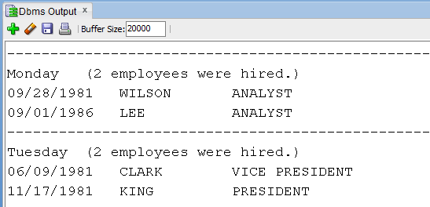

3b) (CSC 452 only – 50 points)

Based on the tables created in Assignment #1, write a PL/SQL anonymous block that displays all employees who were hired on the days (except Saturday and Sunday) of the week on which the lowest number of employees were hired. The output of the program should contain all the hire dates, employee names and their corresponding department names, jobs, and manager names. Sort the data by days of the week and the hire date.

Hard coding (e.g., IF v_day = 'Monday' OR v_day = 'Tuesday' OR total_num = 2 THEN …) will get a zero point.

Hints:
(a) TO_CHAR(hire_date, 'Day')
(b) TO_CHAR(hire_date,'MM/DD/YYYY')
(c) WHERE TRIM(TO_CHAR(hire_date, 'Day')) != 'Sunday' AND
TRIM(TO_CHAR(hire_date, 'Day')) != 'Saturday'

The output of your program must match the following:

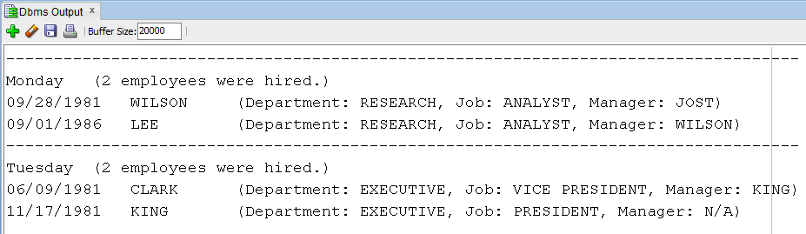

4) ) (CSC 452 only – 30 points)

a) (0 points) Create and populate tables DW_USER, DW_PROJECT, and DW_USER_PROJECT as described below.

CREATE TABLE dw_user
(
USER_ID NUMBER PRIMARY KEY,
USER_NAME VARCHAR2(20)
);

CREATE TABLE dw_project
(
PROJECT_ID NUMBER PRIMARY KEY,
PROJECT_NAME VARCHAR2(30));

CREATE TABLE dw_user_project
(
USER_ID NUMBER,
PROJECT_ID NUMBER,
ASSIGNED_ROLE VARCHAR2(20),
PRIMARY KEY (USER_ID, PROJECT_ID, ASSIGNED_ROLE),
FOREIGN KEY (USER_ID) REFERENCES dw_user(USER_ID),
FOREIGN KEY (PROJECT_ID) REFERENCES dw_project(PROJECT_ID));

INSERT INTO dw_user VALUES(1, 'JACKSON');
INSERT INTO dw_user VALUES(2, 'LANCASTER');
INSERT INTO dw_user VALUES(3, 'JONES');
INSERT INTO dw_user VALUES(4, 'MILLER');
INSERT INTO dw_user VALUES(5, 'JOST');
INSERT INTO dw_user VALUES(6, 'WHITE');
INSERT INTO dw_user VALUES(7, 'FISHER');
COMMIT;

INSERT INTO dw_project VALUES(1, 'COLWeb R8');
INSERT INTO dw_project VALUES(2, 'Wiki V7.0');
INSERT INTO dw_project VALUES(3, 'CDM Intranet Beta');
COMMIT;

INSERT INTO dw_user_project VALUES(1, 1, 'Developer');
INSERT INTO dw_user_project VALUES(1, 2, 'Tester');
INSERT INTO dw_user_project VALUES(2, 1, 'Tester');
INSERT INTO dw_user_project VALUES(2, 2, 'Developer');
INSERT INTO dw_user_project VALUES(3, 1, 'Manager');
INSERT INTO dw_user_project VALUES(3, 2, 'Manager');
INSERT INTO dw_user_project VALUES(3, 2, 'Developer');
INSERT INTO dw_user_project VALUES(1, 3, 'Developer');
INSERT INTO dw_user_project VALUES(4, 2, 'Developer');
INSERT INTO dw_user_project VALUES(4, 2, 'Tester');
INSERT INTO dw_user_project VALUES(4, 3, 'Manager');
INSERT INTO dw_user_project VALUES(4, 3, 'Developer');
INSERT INTO dw_user_project VALUES(4, 3, 'Tester');
INSERT INTO dw_user_project VALUES(7, 3, 'Tester');
COMMIT;

b) (30 points) Write a PL/SQL anonymous block to display “user_name”, “project_name”, and “assigned_role”. Sort your output by the “user_name”, “project_name”, and “assigned_role”

Make sure that 1) each user name only displayed once, and 2) each project name under the same user name only displayed once. You will lose 10 points if you fail to do so.

Make sure that users who have not been assigned to any project are included as well.

The output of your program must match the following:

